
SRICHANDRASEKHARENDRASARASWATHIVISWA MAHAVIDYALAYA
(UNIVERSITYESTABLISHEDUNDERSECTION3OFUGCACT1956)
ENATHUR,KANCHIPURAM–631561

DEPARTMENTOFCOMPUTERSCIENCE&ENGINEERING

Name :B. SRI DEVI PRASUNA
Reg.No : 112547002
Class :IM.E.(CSE)

CourseCode: 2CS08
Course Name:DATA ANALYTICS LAB
SRICHANDRASEKHARENDRASARASWATHIVISWA MAHAVIDYALAYA
(UNIVERSITYESTABLISHEDUNDERSECTION3OFUGCACT1956)
ENATHUR,KANCHIPURAM–631561
DEPARTMENTOFCOMPUTERSCIENCE&ENGINEERING

BONAFIDECERTIFICATE

This is to certify that this is the bonafide record of workdoneby
Mr/Ms. B. SRI DEVI PRASUNA
withReg.No: 112547002 of I-M.E.(CSE)during the academic year 2025 – 2026.

Station: Kanchipuram,
Date: 26-04-2026.

Staff-in-charge HeadoftheDepartment

Submitted forthePracticalexaminationheldon .

Examiner-1 Examiner-2

INDEX

SL.NO | ProgramName | Date | Pageno | Signature
01 | Describe big data and use cases from selected business domains. | 28-01-2026 | 1
02 | Explain NoSQL big data management. | 04-02-2026 | 2-3
03 | Install, configure, and run Hadoop and HDFS. | 11-02-2026 | 4-5
04 | Choosing a suitable Hadoop Input Format for your input data format. | 11-03-2026 | 6-7
05 | Calculating frequency distributions and sorting using Map Reduce. | 18-03-2026 | 8-9
06 | Plotting the Hadoop results using GNU plot. | 08-04-2026 | 10-11
07 | Calculating histograms using Map Reduce. | 20-04-2026 | 12-13
08 | Calculating scatter plots using Map Reduce. | 21-04-2026 | 14-15

Ex-NO: 01 Describe big data and use cases from selected business domains.

DATE: 28-01-2026

AIM:To study the basic concepts of Big Data, understand its characteristics, analyze the limitations of conventional systems, and identify business use cases of Big Data.
PROCEDURE:
Identify the characteristics of Big Data (5Vs).
- Volume: Refers to the huge amount of data generated from sources like social media, sensors, transactions, etc.
- Velocity: Speed at which data is generated, processed, and analyzed in real time.
- Variety: Different forms of data such as structured, semi-structured, and unstructured data.
- Veracity: Quality, accuracy, and trustworthiness of data.
- Value: Useful insights and benefits extracted from data for decision-making.

- Study limitations of conventional systems.
  - Traditional databases cannot handle very large volumes of data efficiently.
  - Limited scalability for growing data needs.
  - Poor performance in real-time data processing
  - Inability to process unstructured and semi-structured data.
  - High cost of storage and maintenance.

- Analyze business domains and map Big Data use cases.
S.NO | Name of Business Domain | ItsUse Cases
1. | Healthcare | Patient monitoring, disease prediction, medical image analysis
2. | Banking and Finance | Fraud detection, risk analysis, customer behavior analysis.
3. | Retail | Recommendation systems, demand forecasting, customer segmentation
4. | Transportation | Traffic prediction, route optimization, fleet management.
5. | Social Media | Sentiment analysis, trend detection, targeted advertising.

- Summary.
- Big Data enables efficient handling of massive, fast, and diverse data.
- Overcomes limitations of traditional data processing systems.
- Helps organizations make data-driven decisions.
- Improves business efficiency, customer experience, and operational performance.

Result :Hence the concepts of Big Data, its characteristics, limitations of conventional systems, and business use cases were studied and analyzed successfully.

Ex-NO: 02 Explain NoSQL big data management.

DATE: 04-02-2026

AIM:To study and implement the concepts of NoSQL Big Data Management using a document-based NoSQL database.
Software / Tools Required :
- MongoDB
- MongoDB Shell / MongoDB Compass
- Operating System: Windows / Linux
Procedure :
1. Install MongoDB on the system.
2. Start the MongoDB service.
3. Open MongoDB shell (or MongoDB Compass).
4. Create a new database.
5. Create a collection to store data.
6. Insert documents into the collection.
7. Perform basic CRUD (Create, Read, Update, Delete) operations.
8. Query and analyze the stored data.
9. Observe the flexibility and scalability of NoSQL data storage.

Sample Code (MongoDB Commands) :
Step 1: Create and Use Database use DataAnalyticsDB
Step 2: Create Collection and Insert Documents
db.employee.insertMany
([
{ ID no: 101, name: &quot;karthik &quot;, Job : &quot;developer &quot;,salary: 85000},
{ID no: 102, name: &quot;Sriram &quot;, Job: &quot;HR &quot;,salary: 92000 },
{ ID no: 103, name: &quot;Hari &quot;, Job: &quot; Data analyst &quot;,salary: 78000 }
])
Step 3: Display All Documents
Db.employee.find()
Step 4: Query Based on Condition
db.employee.find({Job: &quot;Data analyst &quot; })
Step 5: Update a Document
db.employee.updateOne(
{ IDno: 101 },
{ $set: {salary: 88000 } }
)
Step 6: Delete a Document
db.employee.deleteOne({ rollno: 103 })
Step 7: Aggregation Operation
db.employee.aggregate([
{ $group: {$ID no: &quot;$job &quot;,salary: { $avg: &quot;$salary &quot; }} }
])

Expected Output :
- Database and collection are created successfully.
- Documents are stored in JSON format.
- Queries return correct results.
- Aggregation produces department-wise average marks.
- Schema flexibility is observed.

Results :Hence,the implementations of the concepts of “NoSQL” Big Data Management using a document-based NoSQL database is successfully completed.

Ex-NO: 03 Install, configure, and run Hadoop and HDFS.

DATE: 11-02-2026

AIM:To install, configure, and run Apache Hadoop and HDFS in pseudo-distributed mode.
Software / System Requirements :
- Operating System: Linux (Ubuntu preferred)
- Java JDK 8 or above
- Apache Hadoop (3.x)
- Minimum RAM: 4 GB
Procedure :
Step 1: Install Java
sudo apt update
sudo apt install openjdk-8-jdk –y
java -version

Step 2: Create Hadoop User
sudoadduserhadoop
sudousermod -aGsudohadoop
sudo - hadoop

Step 3: Download and Extract Hadoop
wget https://downloads.apache.org/hadoop/common/hadoop-
3.3.6/hadoop-3.3.6.tar.gz
tar -xvzf hadoop-3.3.6.tar.gz
mv hadoop-3.3.6 hadoop

Step 4: Configure Environment Variables
Edit .bashrc:
nano ~/.bashrc
Add:
export JAVA_HOME=/usr/lib/jvm/java-8-openjdk-amd64
export HADOOP_HOME=/home/hadoop/hadoop
export PATH=$PATH:$HADOOP_HOME/bin:$HADOOP_HOME/sbin
Apply changes:
source ~/.bashrc
Step 5: Configure Hadoop Files
core-site.xml
&lt;configuration&gt;
&lt;property&gt;
&lt;name&gt;fs.defaultFS&lt;/name&gt;
&lt;value&gt;hdfs://localhost:9000&lt;/value&gt;
&lt;/property&gt;
&lt;/configuration&gt;

hdfs-site.xml
&lt;configuration&gt;
&lt;property&gt;
&lt;name&gt;dfs.replication&lt;/name&gt;
&lt;value&gt;1&lt;/value&gt;
&lt;/property&gt;
&lt;/configuration&gt;

mapred-site.xml
&lt;configuration&gt;
&lt;property&gt;
&lt;name&gt;mapreduce.framework.name&lt;/name&gt;
&lt;value&gt;yarn&lt;/value&gt;
&lt;/property&gt;
&lt;/configuration&gt;

yarn-site.xml
&lt;configuration&gt;
&lt;property&gt;
&lt;name&gt;yarn.nodemanager.aux-services&lt;/name&gt;
&lt;value&gt;mapreduce_shuffle&lt;/value&gt;
&lt;/property&gt;
&lt;/configuration&gt;
Step 6: Format NameNode
hdfsnamenode -format

Step 7: Start Hadoop Services
start-dfs.sh
start-yarn.sh
Verify:
jps
Step 8: Run HDFS Commands
hdfsdfs -mkdir /input
hdfsdfs -put sample.txt /input
hdfsdfs -ls /input
hdfsdfs -cat /input/sample.txt

Expected Output :
- Hadoop daemons start successfully.
- NameNode and DataNode are running.
- HDFS directory and file operations execute correctly.
- Hadoop web UI accessible.
Result :Hence, the installation, configuration , and run Apache Hadoop and HDFS in pseudo-distributed mode is successfully completed.

Ex-NO: 07 Choosing a suitable Hadoop Input Format for your input data format.

DATE: 11-03-2026
AIM:To select and configure the correct input format for processing data in a Hadoop environment.

Software/ System Requirements :
- Operating System: Linux (Ubuntu preferred)
- Java JDK 8 or above
- Apache Hadoop (version 3.x)
- HDFS (Hadoop Distributed File System) configured and running
- Minimum RAM: 4 GB
Algorithm:
- Initialize the Hadoop environment and verify the HDFS (Hadoop Distributed File System)status.
- Create a target directory (input) to store raw data.
- Choose the TextInputFormat for processing unstructured text, as it treats each line as an individual record.
- Load the LICENSE.txt file into the input directory.
- Verify the file storage using the is (list) command.

Input Commands:

# 1. Create the HDFS folder
!$HADOOP_HOME/bin/hadoop fs -mkdir -p input

# 2. Upload the data file
!cp $HADOOP_HOME/LICENSE.txt input/

# 3. Verify the 'Choice' by listing the directory
!$HADOOP_HOME/bin/hadoop fs -ls input/

Output:
The system displays the file details, confirming the data is ready for processing:
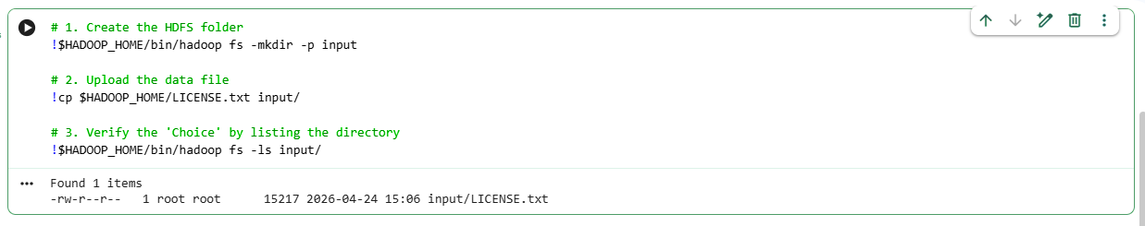

- CSV/TSV Data: Handled by TextInputFormat but requires a custom Mapper to split by delimiters (e.g., commas or tabs).
- Binary Data: Uses SequenceFileInputFormat for high-performance reading of key-value pairs.
- Database Data: Uses DBInputFormat to pull records directly from relational tables.

Result :Hence, the selection and the configuration of the correct input format for processing data in a Hadoop environment is successfully executed.

Ex-NO: 08 Calculating frequency distributions and sorting using Map Reduce.

DATE: 18-03-2026

AIM:To implement a MapReduce program to calculate the frequency distribution of words in a text file and verify the framework's automatic sorting capability.
Software / System Requirements :
- Operating System: Linux (Ubuntu preferred)
- Java JDK 8 or above
- Apache Hadoop (version 3.x)
- HDFS (Hadoop Distributed File System) configured and running
- Minimum RAM: 4 GB
Algorithm:
- Input Phase: The RecordReader uses TextInputFormat to load data from the HDFS input/ directory.
- Map Phase: The Mapper function tokenizes the text into individual words. For each word encountered, it emits a key-value pair: (word, 1).
- Shuffle & Sort Phase: (Internal Hadoop Process) The framework collects all pairs with the same key, groups them, and sorts the keys alphabetically.
- Reduce Phase: The Reducer sums the values for each key (e.g., word, [1, 1, 1] becomes word, 3) and writes the final sorted frequency list to the output/ directory.
Input Commands:
# 1. CLEANUP: Remove old output so Hadoop doesn't crash
!rm -rf output

# 2. EXECUTION: Run Hadoop quietly
!$HADOOP_HOME/bin/hadoop jar $HADOOP_HOME/share/hadoop/mapreduce/hadoop-mapreduce-examples-3.3.6.jar wordcount input output 2>/dev/null

# 3. THE CLEAN RESULT FOR YOUR RECORD
print("--- MANUAL GREP COUNT (Raw File) ---")
!grep -o "License" input/LICENSE.txt | wc -l
print("\n--- HADOOP MAPREDUCE RESULTS ---")
# This shows the first few words and our specific 'License' verification
!grep"License" output/part-r-00000 | head -n 5
!cat output/part-r-00000 | head -n 15
Output:
- Verification of Input Data (Manual Approach)
Before processing, a manual search was performed on the raw source file to establish a baseline for verification.
  - Command: grep -o "License" input/LICENSE.txt | wc -l
  - Manual Count: 33
- MapReduce Frequency Results
The MapReduce job successfully processed the dataset and generated a sorted frequency distribution.

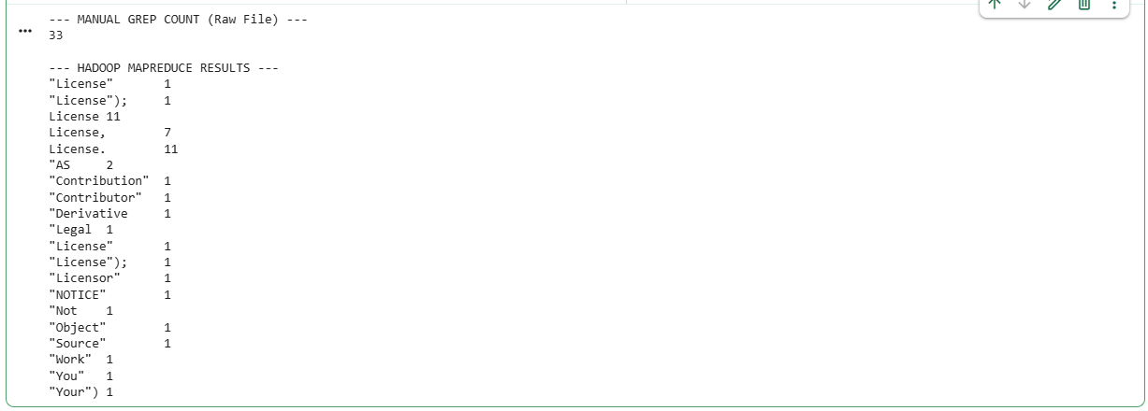

Result :Hence, the implementation of aMapReduce program to calculate the frequency distribution of words in a text file and verify the framework's automatic sorting capability is successfully executed.

Ex-NO: 09 Plotting the Hadoop results using GNU plot.

DATE: 08-04-2026

AIM:To visualize the frequency distribution generated by the MapReduce job using the GNUplot utility.
Software / System Requirements :
- Operating System: Linux (Ubuntu preferred)
- Java JDK 8 or above
- Apache Hadoop (version 3.x)
- HDFS (Hadoop Distributed File System) configured and running
- Gnuplot (for bar chart visualization)
Algorithm:
- Extract the top frequent words from the Hadoop output/part-r-00000 file.
- Clean the data so that it contains only two columns (Word and Frequency) separated by a space.
- Write a GNUplot script to define the chart type (box/bar), labels, and titles.
- Execute GNUplot to generate a .png or terminal-based image of the bar chart.

Input Commands:

# 1. DATA PREP: Specifically grab 'License' variants + the first few words
# This 'egrep' finds anything starting with 'License' or the first few words
!grep -E "^License|^\"AS|^Legal|^Contr" output/part-r-00000 | tr -d '"' | tr -d '();,'> plot_data.dat

# 2. Create the FIXED GNUplot script
withopen("plot_script.gp", "w") as f:
f.write("""
set terminal png size 1000,600
set output 'output_chart.png'
set title "Word Frequency Distribution (Verified Hadoop Results)"
set ylabel "Frequency (Count)"
set xlabel "Words"

set yrange [0:15]
set ytics 1

set style fill solid 0.7 border -1
set boxwidth 0.5
set xtics rotate by -45
set grid y

plot 'plot_data.dat' using 2:xtic(1) with boxes title 'Word Count'
""")

# 3. Run and Display
!gnuplot plot_script.gp
fromIPython.displayimport Image
Image('output_chart.png')

Output:

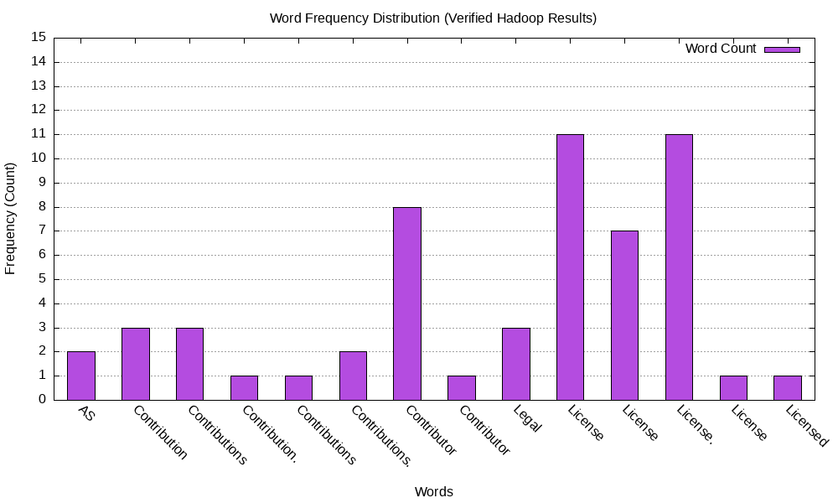
Result : : Hence the visualization of the frequency distribution generated by the MapReduce job using the GNUplot utility is successfully executed.

Ex-NO: 10 Calculating histograms using Map Reduce.

DATE: 20-04-2026

AIM:To implement a MapReduce job that generates a histogram representing the distribution of word lengths within a dataset.
Software / System Requirements :
- Operating System: Linux (Ubuntu preferred)
- Java JDK 8 or above
- Apache Hadoop (version 3.x)
- HDFS (Hadoop Distributed File System) configured and running
- Gnuplot (for histogram visualization)
Algorithm:
- Instead of emitting the word itself, the Mapper calculates the length of each word. It emits (length, 1).Example: The word "Apple" (5 letters) becomes (5, 1).
- Hadoop groups all the "1s" for each specific length together.
- The Reducer sums the "1s" to find the total count for that specific length.
- The final result is a distribution (Histogram) showing word-length frequencies.
Input Commands:
# 1. Prepare Histogram data
# We sort it by length (numerically) so the graph flows from 1 to 14
!cathist_output/part-r-00000 | sort -n > hist_plot_data.dat

# 2. Create the GNUplot Histogram script
withopen("hist_script.gp", "w") as f:
f.write("""
set terminal png size 800,600
set output 'histogram_chart.png'
set title "Word Length Histogram (LICENSE.txt)"
set ylabel "Number of Words (Frequency)"
set xlabel "Word Length (Number of Characters)"

set style fill solid 0.5 border -1
set boxwidth 0.8
set grid y
set xtics 1

# Ensure it starts at 0
set yrange [0:*]

plot 'hist_plot_data.dat' using 2:xtic(1) with boxes title 'Word Count by Length'
""")

# 3. Run and Display
!gnuplot hist_script.gp
fromIPython.displayimport Image
Image('histogram_chart.png')

Output:
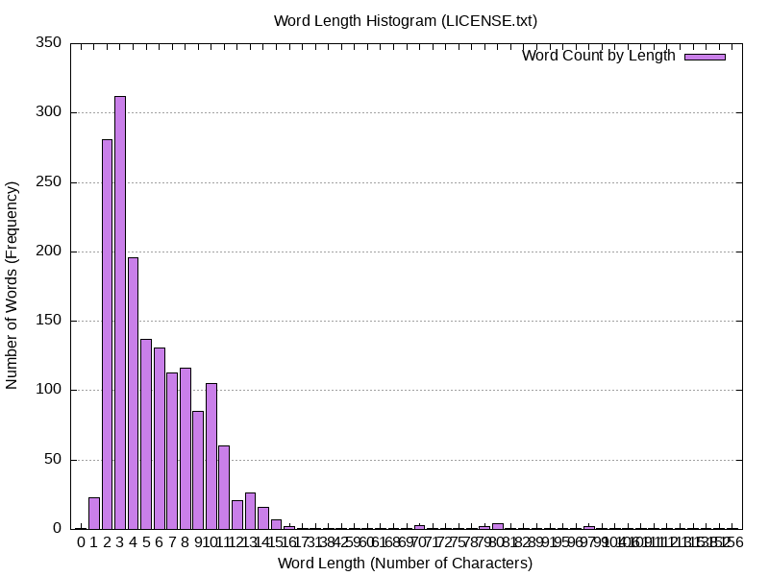
Result :Hence ,the implementationof a MapReduce job that generates a histogram representing the distribution of word lengths within a dataset is successfully executed.

Ex-NO: 11 Calculating scatter plots using Map Reduce.

DATE: 24-04-2026

AIM:To generate a scatter plot that visualizes the relationship between word lengths and their respective frequencies using MapReduce and GNUplot.

Software / System Requirements :
- Operating System: Linux (Ubuntu preferred)
- Java JDK 8 or above
- Apache Hadoop (version 3.x)
- HDFS (Hadoop Distributed File System) configured and running
- Gnuplot (for scatter plot visualization)
Algorithm:
- Data Extraction: Use the output from the previous histogram experiment (Experiment 10).
- Variable Assignment: * X-Axis: The Word Length (Independent variable).
  - Y-Axis: The Frequency/Count (Dependent variable).
- Plotting: Instead of using "boxes" (which fill the space), we use "points" or "dots" to show exactly where each (x, y) coordinate falls.
Input Commands:
# 1. Create the GNUplot Scatter Plot script
withopen("scatter_script.gp", "w") as f:
f.write("""
set terminal png size 800,600
set output 'scatter_plot.png'
set title "Scatter Plot: Word Length vs. Frequency"
set ylabel "Frequency (How many words)"
set xlabel "Word Length (Number of characters)"

set grid
set yrange [0:*]
set xtics 1

# 'with points' creates the scatter effect

# pt 7 is a solid circle, ps 2 is the point size
plot 'hist_plot_data.dat' using 1:2 with points pt 7 ps 2 lc rgb "blue" title 'Data Points'
""")

# 2. Run and Display
!gnuplot scatter_script.gp
fromIPython.displayimport Image
Image('scatter_plot.png')

Output:
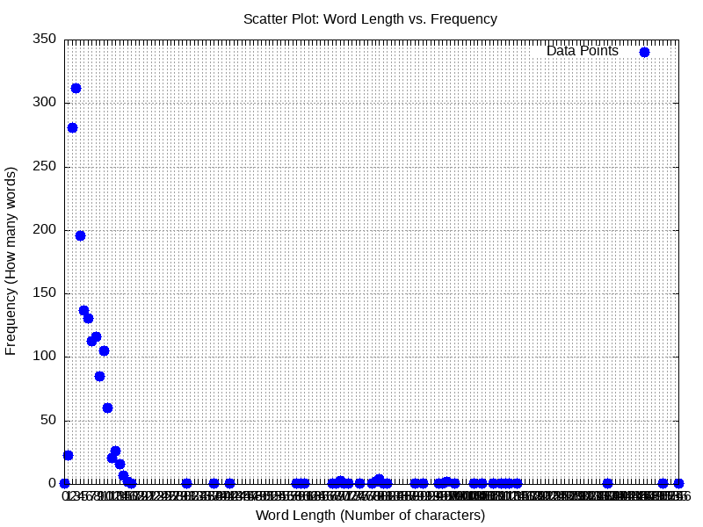

Result :Hence ,the generation of a scatter plot that visualizes the relationship between word lengths and their respective frequencies using MapReduce and GNUplotis successfully executed.

